
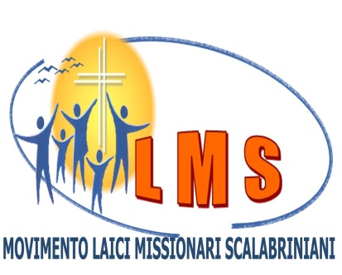
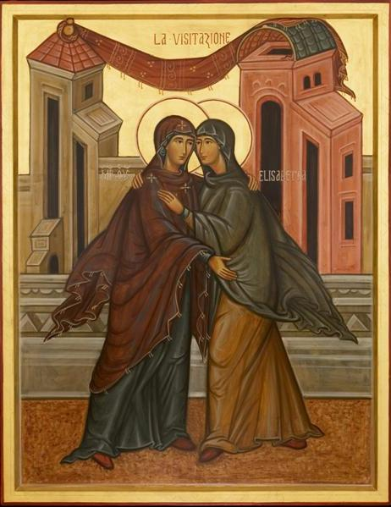
VISIBILITY OF THE CHARISM IN LIFE AND MISSION OF THE LAY SCALABRINIAN MISSIONARY
IVth GENERAL ASSEMBLY
PIACENZA – ITALY
05 to 09 September 2012
“Go fast messengers….to the people who await you” Scalabrini

Scalabrini

Scalabrini
.”
Scalabrini

Mary arose and went with haste to the house of Elisabeth (Luke 1,39)
08/09/12

- 7h30min Morning prayer – GMMM
- 8h Breakfast
- 8h30min Presentation of the new General Coordination and General Councillors
Definition and vote of the priorities
- 10h Break
- 10h15min Presentation and vote of the FINAL DOCUMENT
Prayer - GNSF
- 12h30min Lunch
- 13h30min Pilgrimage - Caravágio
- 19h30min Supper
- 20h30min Concert: “Go Scalabrini”

09/09/12

- 7h45min Morning prayer – GNSA
- 8h Breakfast
- 8h30min Observations and Evaluation of the IVth Assembly
Closing speech
- 11h Closing Mass
Blessing and Sending - GSG
CONGREGATION
Missionary Sisters of St Charles Borromeo – Scalabrinians

PLACE OF THE ASSEMBLY
Centro Pastorale Diocesano “LA BELLOTTA“
On the way to Valconasso 10 - Pontenure
Piacenza – Itália
Tel. 0039/0523/517110

Piacenza - Italy

PROGRAM
05/09/12
During the day: registration and lodging
- 19h Supper
- 20h Opening Prayer - GSG
- 20h30min Opening speech
Welcoming and presentation of the members of the IVth General Assembly.
Instrumentum Laboris.

06/09/12

- 7h45min Breakfast
- 8h15min Celebration – invoking the Holy Spirit – GCR
- 8h45 min Retreat – “Mary arose and went with haste to the house of Elisabeth” (Luke 1,39) Giuseppe Morsia – General Vice-Coordinator LMS
-10h30 min Break
-10h45 min Brief report of the IIIrd GENERAL ASSEMBLY
-11h15 Migration realities
Report GNSA (10 min)
Report GIC (10 min)
Report GNSF (10 min)
Report GSG (10 min)
Report GMMM (10 min)
Report GCR (10 min)
-12h15min Prayer - GNSF
-12h30min Lunch
-14h Prayer – GNSA
Talk: Situation in the world of the migration reality - Dr. Massimo Magnaschi
-15h30min Break
-16h Report of GMMM (15 min)
Report of GSG (15 min)
Report of GNSA (15 min)
Report of GCR (15 min)
- 17h - Report of GNSF (15 min)
Report of GIC (15 min)
- 17h30min Complementation and Feed-back
- 18h45min Prayer – GIC
- 19h30min Supper
- 21h Sharing of Scalabrinian experiences

07/09/12

- 8h Breakfast
- 8h30min Prayer - GNSA
- 8h45min Round table discussion
Expression of the scalabrinian charism in...
...the charism given to the Blessed Scalabrini and to the Lays of the St. Raphael Society
...the scalabrinian charism and the Mission of the Lay Scalabrinian Missionary Movement today.
...how is the scalabrinian charism expressed today in the missionary activity of the Lay Scalabrinian Missionary Movement in the world.
- 10h Break
- 10h15min Report of the General Council of the MLMS
- 11h Decisions: General Directions and general topics
- 12h15min Prayer - GMMM
- 12h30min Lunch

- 14h Prayer - GIC
Decisions: General Directions
Process of Movement’s recognition
Priorities for the next three years (2012/2015)- 17h Break
- 17h30min We go to the Bishop’s office
- 18h Mass with the Bishop of Piacenza and
Celebration of membership commitment
- 19h30min Supper
- 20h Elections of the General Coordination and of the New General Council

