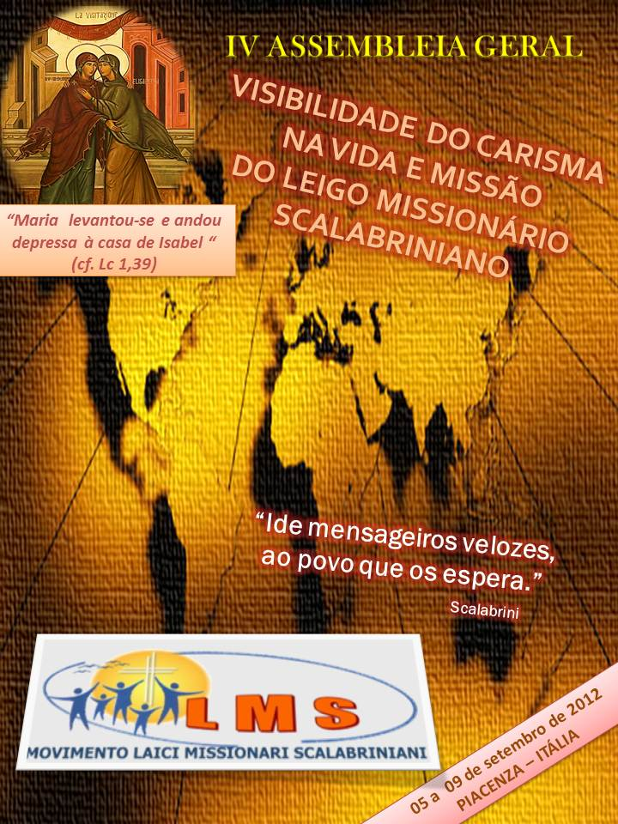
FINAL DOCUMENT
INTRODUCTION

From 05 to 09 September 2012, was held the IVth General Assembly of the Scalabrinian Lay
Missionary Movement at the Diocesan Pastoral Center, “La Bellotta” Strada per Valconasso,10 - Pontenure - Piacenza, Italy. 25 Lay Scalabrinians and 2 listeners/observers, coming from 13 countries and 4 continents and 08 Scalabrinian Sisters, Sr. Alda Monica Malvessi, General Superior, was present at the opening session - through a letter - designated to the group with her encouraging and motivating words in view of the future journey. And the following Sisters were present: Sr. Zenaide Ziliotto, Rome, General Missionary Vicar of San Charles Borromeo Scalabrinians - and General Councillor of the SLM Movement; the Provincial Superior Sr. Lina Guzzo of the Province San Giuseppe Italy; the Councillors of the Groups: Sr. Ana Maria Delazeri, Group Maria, Mãe dos Migrantes, Caldas Novas GO –BR; Sr. Milva Caro, Bochum – Germany, Group S. Giuseppe; Sr. Elisabeth Pederrnal, Chicago USA, Councillor of the Group Our Lady of Fatima; Sr. Maria Isabel Arante, São Paulo, SP-BR, Councillor of the Group Nossa Senhora Aparecida; Sr. Egidia Muraro, Porto Alegre, RS-BR, Councillor SLM of the Province Cristo Rei and Sr. Clecy Baccin, Caxias do Sul, RS-BR, Councillor SLM of the Group Imaculada Conceição.

The IVth General Assembly had the central theme: “The visibility of the Charism in life and mission of the Scalabrinian Lay Missionary “Go fast messengers ...the people await you (Scalabrini).
General objective was to “Strengthen the charism in the life and mission of the Scalabrinian Lay Missionary, for a deeper consolidation of the Movement”, highlighting, as follows: to create strong moments of inter-relation, making possible the sharing and the union of the SLM Movement; to experience strong moments of spiritual formation; to reflect on the actual context of the human mobility and on the mission of the Scalabrinian Lay Missionary; to evaluate and to define concrete aspects of the organization of the Movement; to look for the integration with the local community since the celebrations and cultural moments; to plan the journey of the Movement for the next three years 2012-2015, where these following aspects will be of great importance: the mission, the formation, the organization, the economy/financial support and the communication.

IDENTIFICATION

The SLM Movement has an international structure and carries out its actions in Europe, America, Africa and Asia. At this moment the movement is made up of 6 Groups, of 53 Nucleus. 775 Lays belong at this moment to the Movement.
We Scalabrinian Lay Missionaries are attentive and sensitive to the migration phenomena and to the life, origin and background of the people in mobility. The welcoming is our visiting card and our mission is to witness and to announce the love of God among the migrants. We are always committed to the service for the migrants, in different ways like the creativity, the necessity and the scalabrinian charism provoke in the different contexts.
We are called to live in a special way the vocational call to the baptism, through the participation and the sharing of the Scalabrinian Charism, announcing Jesus Christ and giving witness to the identity of SLM in the different aspects of daily life and in the missionary commitment with the migrants.
We share as lays committed to the world of migration, the same vocation, charism and mission of the Missionary Sisters of San Charles Borromeo Scalabrinians, becoming voice for whom has no voice and to stay at the side of those who are the weakest and next to the migrants, above all the poorest and abandoned in order to defend their human dignity and citizenship.
It is a gift to serve the migrants in communion with the local Church and in collaboration with the Congregation.

MIGRATION REALITIES

The clear picture of the migration reality presented through the report of dott. Massimo Magnaschi, tells us that among seven billions of people there are 202.000.000 of migrants in the whole world and circa 44 millions among refugees and displaced people and that in 2030 the European migration balance may have an increase at the pace of 6-7 millions each year.
The migration perspectives, which await us in the future, tell us that the tendency in many developing countries will transform countries of emigration into countries of immigration. Asia will become the greatest country of immigration and Africa the great reservoir of emigration.
However, what should be the responsibility of the governments and which should be the migration politics for the future? Which are the “protection acts” for the migrants, for their families and the future generations? What is the migration realty mentioned above telling us? How do we think to face such challenges as a committed Movement in the world and realities of migrations? Which is the space to be attentive towards the migrant, in a situation of globalized and inter-religious context?
These are the challenges that the actual and future migration realities are offering us to our reflection for the commitment of the Movement for the migrants.

SPIRITUALITY

The Word of God is encouraging and provokes our being SLM and proposes us a God outside of the temple, outside from holy plans, outside from controlled rituals. There is a God, who is on the journey with us in order to do the encounter with who is different from us, who is poor and who is the migrant. God who brings joy to the big and little ones, who makes exult and sing: this is the God we want to announce and serve, we want to proclaim and to recognize actively in our history.
The Scalabrinian Lay Missionary, who lives intensively the life of the movement and of the ecclesiastic community, who turns his/her eyes towards Christ and reflects on the pedagogic of incarnation, on his/her way to approach the man on the street to Emmaus, discovers that needs to ritualise the gestures of the Wayfarer, who reaches out to the others in order to make burn the heart in the chest and provokes the desire to make the encounter with Christ.
He/she has to ritualize the gestures of the good Samaritan and “become close”, “become the neighbour”, of the “Wayfarer” who we find injured on the streets of the world and “pours oil and wine” on the injuries “setting the injured on its own beast” and totally “taking care” for, for his injuries until the moment they are not healed.
Therefore, we need to get out of ourselves, we have to go to the streets, we have to visit the places, where the people have no place where to go or to stay, we need to live and to walk, to know and to meet who is in need and “become his/her neighbour”.
This is when Mary went to help Elisabeth, who was in need, this has to make us think seriously of our task in the Church as lays and we have to pass from the temple, holy place to the street, this means to the world, this is where the man lives, who is above all poor and migrant, with his/her certainties and doubts, his/her conquers and defeats: this is the way of the pastoral action to which we need to be inclined in order to be faithful witnesses of the charism that we profess.
Mons. Scalabrini is at the station in Milan, which is the meeting place of long and different journeys and discovered the drama of the emigrations and of the migrants. It is the station, place of waiting, of halt and however of reflection, of departures and of arrivals, the symbolic place of our encounter, of our being together, of our being Church, the place of departure and of arrival of our missionary journeys and of our apostolic joys and concerns.
The attention to the street and to the station needs to become central objective in order to live the vocation of SLM and must be lived by each of our groups and by each one of us, because in them converges our vocation and mission; this is the place of witness of charity; the place of evangelization; the place, where we can become wayfarers in order to approach the man, our brother, the wayfarer.
For a living and loving Movement, which wants to transmit the love of God, as it is ours towards the world of the migrants, towards all the people, who are homeless, who have no land, who have no abode, towards the world of the human mobility, where the street becomes the place of his/her pilgrimage, the place where to proclaim the prophecy of the Reign and to express his/her service.

MISSION OF THE SLM

In this IVth General Assembly, before the Bishop of Piacenza, successor of Blessed Scalabrini and in the same Chapel, where the first four Sisters MSCS were sent to the mission, 20 members of the Movement confirmed with their public promise, to belong effectively to the Movement, to welcome the call and the apostolic mission/sending as gift of God. Following their example, we live with availability and joy, being at service of the migrants in need, giving a specific expression to our call of baptism.
We carry out or mission, being witnesses of our Christian and ethic commitment, through donation, love, solidarity, welcoming, wholistic promotion of the person of the migrant. We are committed to carry out concrete actions and to make aware the community and the society for a respectful and open welcoming, showing solidarity with the migrants and with the refugees, in a migration context that is becoming more and more complex.
We witness the identity SLM in different daily life aspects and missionary commitment, so that “all peoples may become one and the whole humanity may become one family under the guide of the one shepherd”.
During the General Assembly the coordinators of the six SLM groups presented the most important activities, carried out in favour of the migrants.
These experiences are the living expression of the scalabrinian charism in the world of the human mobility and characterize the missionary action of the Scalabrinian Lay Missionary Movement
The principal actions, which emerged are related to:
- the welcoming, the support, the accompaniment of migrants of different religions, cultures and ethnic groups, in the welcoming centres and the attention and care towards the migrant;
- the support and the accompaniment during the search of work above all in the construction and domestic work areas;
- the visits to the sick in the hospitals, in the elderly homes, in the hospitals and prisons;
- the defence of the migrants’ human rights through social and legal assistance;
- the carrying out of a migration pastoral in the dioceses and parishes, social and pastoral, local and international networking in favour of the migrants and their families;
- the celebration of the Week of the migrant and National Day and World Day of the migrant;
- the active presence in the centres of social communication, to make aware the civil society regarding the migration phenomena and the scalabrinian mission;
- the creation of welcoming centres for orientation, for listening, for documentation and for language study;
- the promotion of campaigns for collecting clothing, food, for the construction of houses and looking for lodging;
- the support, the accompaniment and integration: ecclesiastic in the parishes of belonging, of the students at school and of the adults in the social and working areas.

ACTION PLAN FOR THE THREE YEARS 2012 to 2015

Challenges:
- Recognition by the Congregation of the Religious of the “Statute of the SLM”
- Pastoral Project of the Movement

- to promote and to present the activities of the Movement with the migrants;
- to pass from a service for the migrants to a service with the migrants;
- to make aware about charism and being SLM ?
- to witness through life the belonging to Christ and to MSLM;
- to give rise to the desire among the youth to listen and to welcome the call of God;

- To write the history of the movement
- To consolidate the organization of the Groups since the basis (nuclei) to launch again the expansion of the Movement in a more systematic and organized way:

- to determine and to develop the competences and functions of the responsible groups/institutions;
- to encourage the people that approach the Nuclei to participate and to stay;
- to know and to deepen the languages in order to communicate better with the members of the Movement but also with the migrants;
- to know how to communicate with the languages of global communication: internet, research motors, electronic mail, etc.

5. Financial support – to promote and to adapt the financial situation to the new proposals of the Statute and General Directives

General Objectives:
to solidify and to fortify the Movement from the basis (Nuclei) in all its dimensions: Formation, Mission, Economy/Financial Support, Communication and Missionary Expansion.

Strategy:

On the basis of the indications of the General Assembly, each group and each nucleus, each one at its level, need to predispose a general project of the activities regarding Mission, Formation, Economy/Financial Support, Communication and Missionary Expansion and to present it to the General Council (for the groups) and to the Group Council (for the Nuclei)and to present to the General Council (for the Groups) and to the Council of the Group (for the Nuclei).

When: at the beginning of the three years plan at long term, each year for the medium term and during the year for the short term.

How: in tune with the Church, with the movement, with the Congregation and the migration reality where the Nucleus is present .

Mission:
  - to develop the missionary project in tune with the local realities according the pastoral project of the local Church and of the Congregation MSCS;
  - to collaborate at a local level through the exchange of experiences and actions with other groups;
  - to put into action strategies in order to create a pastoral of attention/care towards the migrant within the parishes.

Formation:

- to have at disposal of the Movement a formation project for the formators to be developed in the Groups with each responsible of the formation of each Nuclei;
- to utilize the formation manual as a basic mean for the formation of the Nucleo;
- to study and to deepen, in the meetings of the Nucleus and of the Group, the migration reality, the documents and life of the Movement: the scalabrinian charism in the dimension of the spirituality and of the mission.

Communication:

Internal:
- to stimulate the use of communication means like electronic mail and teleconference;
- to keep the communication at all the levels of the Movement;
- to send to all the members of the groups the updated e-mail addresses;
- to encourage to more communication at nucleus level and of the groups, sending the news to the general responsible of communication for the publication of the bulletin;
- to ask the adviser Sisters of the Nuclei and of the Groups to facilitate the transmission of information for who does not have access to e-mail and does have no e-mail address;
- to spread the access and the use of sites and blogs of the movement and of the scalabrinian families for information, for the reading and for the diffusion of documents.

External:
a. to be present on the means of communication, including the social nets, at a national and local level for the diffusion of the news towards the external part of the Movement.

Financial support
- to establish a contribution for each Nucleus for the maintenance of the Movement;
- to establish in the project of the Nucleus how to look for funds for the maintenance of the Nucleus, of the group and the General Council;
- to study in the Nuclei the Social Statute proposed by the General Council.

General perspectives and proposals of actions
- to continue the translation and the study of the formation manual;
- to study the Social Statute presented in the IVth General Assembly and to adapt it to the reality of the Group in order to have the possibility to find more financial support for the Nucleus, Group and Movement;
- to make the groups aware to help the Nuclei with main economic difficulties;
- to stimulate the members of the Nucleus for the daily prayer and to say the prayer of the SLM.

CONCLUSION

The Movement of the Scalabrinian Lay Missionary is a reality going forward and in expansion.
In this Assembly we have already made the experience of the strengthening of communion and consolidation within the Movement.
The questions we receive through the Word of God, listened, meditated and shared, are many and we can not take them not in consideration, but we must find immediately actions in order “to put them in practice.“
In the meetings of the Groups and of the Nucleus, we pray and while we break the Bread and the Word, we ask God for light, that he may help us to discern and to put in practice, each member according to his/her reality, what was decided and taken over in the IVth General Assembly and to keep alive our faithfulness to the Charism and to witness with our accomplishment our faith in Jesus Christ.
Only in the light of the faith, in the Eucharist, where Christ becomes bread for us and in the meditation of the Word of God it is possible, at all times and anywhere, to recognize God in him "we live and move and have our being" (Acts 17, 28).
Through the faith and moved by Charity, that comes from God, following the example of Mary, we bring the goodness to all, but in a particular way towards the migrants, centre of our attentions and care and reason of our being together in the SLM Movement.
We fight together with those against the adversities of life. We live and witness the Hope that we receive from Christ, that after the Cross there is the resurrection, that is "...the sufferings of this time are not worth comparing with the glory that is to be revealed to us." (Rom 8,18).
"...God's love has been poured into our hearts through the Holy Spirit who has been given to us" (Rom 5, 5), that we may be able to express really with our life of spirit of the beatitudes and may help us, to reserve to those who are the last and in a special way to the migrants, in virtue of the Charism, we express a welcoming, like that of Elisabeth reserved to Mary “And why is this granted me, that the mother of my lord should come to me?” (Lk 1, 43) and to have the encounter with the migrant as she/he would be Jesus Christ who becomes our guest and our brother awaiting that he at the end of the times may say to us: “...come, oh blessed of my father, inherit the Kingdom prepared for you from the foundation of the world; for I was hungry and you gave me food, I was thirsty and you gave me drink, I was a stranger and you welcomed me..." (Mt 25, 34-35).
Mary, Mother and Companion, on our journey of our walking on the streets in the world and Mother of the Migrants, who has proved and felt the weight of the emigration in her earthly life and the Blessed Scalabrini may be our models, strength and support in the daily efforts of our life and of our work with the migrants.
"May the Lord of peace, give us peace in all times and in all ways! The grace of the Lord our Jesus Christ, may be with us ". AMEN

Piacenza, September 9, 2012

